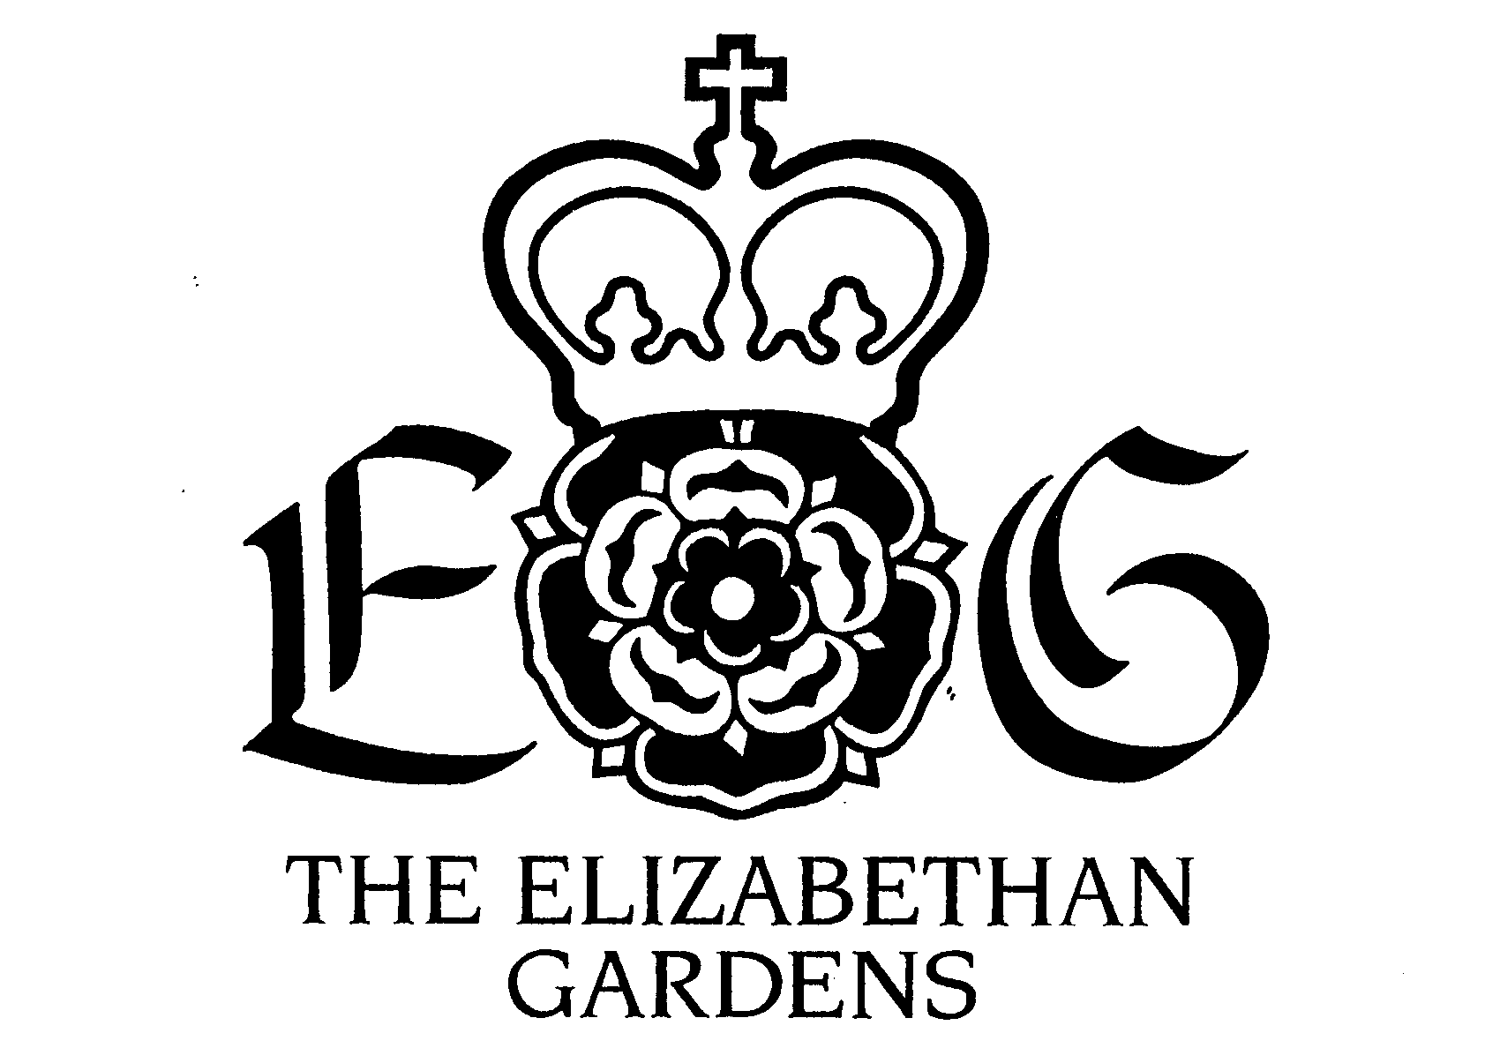

PHOTOGRAPHY POLICY

The Gardens provides a unique backdrop, especially for wedding and engagement photos. The sustainability of The Elizabethan Gardens (a 501c3 nonprofit organization) is dependent on responsibly managing our assets in ways that generate support for our operations. This policy was designed to promote responsible stewardship of The Gardens.

All photography is regulated at The Elizabethan Gardens. A photography fee applies to professional photographers and videographers who are selling images for profit or publication. This fee and policy also applies to any bridal or engagement photos, family portraits, etc. taken by professional or amateur photographers and videographers alike.

Visitors taking non-professional pictures do not need to purchase a permit. It is suggested that you schedule appointments anyway for special occasion photography of homecoming, prom and etc.
The Elizbaethan Gardens reserves the right to refuse admittance for photography and/or to modify this photography policy without advance notice.

Photography for Booked Event Clients

All clients who have booked a ceremony and or reception at The Elizabethan Gardens receive a complimentary two-hour Photography Permit – photographer not included. Portraits are taken and developed by your own photographer. Event clients should contact The Elizabethan Gardens to schedule a time for this session. Additional fees will be charged if a staff member’s assistance is requested for your photo session.

We require a pre-scheduled appointment for all portraits. Appointments can be scheduled by contacting The Elizabethan Gardens at (252) 473-3761.

Photography Permit: $50 for Two Hours (up to four persons)

If you have not booked an event in The Gardens, you will need a Photography Permit. A Photography Permit allows entrance for up to four people (including the photographer and assistants). The regular admission fee is required for additional subjects in the same shoot or for family members and friends who come to watch. Photography is permitted throughout the site, some restrictions apply. Please take note of the photo restriction section of this policy.
Call The Elizabethan Gardens at (252)-473-3761 to schedule your appointment and receive your two-hour permit.

Photo Restrictions

- Do not enter flowerbeds, plant displays or mulched areas.
- Do not climb trees, walls or sculptures.
- Remain on the pathways and grassy lawns at all times.
- Do not disturb or remove plants, plant labels or containers.
- Do not block access to the entrance, pathways, or garden areas.
- Do not disturb any special event or wedding that is taking place in the Gardens during the time of your photo shoot.
- If in doubt, consult the Garden Staff.

Photo Session Courtesy

Remember that visitors are welcome in all public areas and regular business continues during normal operating hours. Other visitors at the Garden also want a pleasant experience. Please be respectful by keeping pathways clear to allow visitor foot traffic. Also remember that any party booking a private event in a particular location in The Gardens during your session has exclusive right to that reserved area. The Garden Staff should alert you to this when you schedule your session.

Additional Considerations

- The representative will be responsible for paying admission for all members of the party for the photography session.
- Reservations must be made at least 48 hours in advance to ensure there are no conflicts.
- If the wedding is being held at The Gardens, the studio fee is included in the site rental. However, if pictures are to be taken at a time different from the wedding or rehearsal, reservations will need to be made.
- All photographs must be taken along regular pathways and public areas. Climbing trees, walls, or sculptures is strictly forbidden. The party paying is solely responsible for any damages done to The Elizabethan Gardens during this session.
- Use of images taken may be used for promotion of the photographer’s business as long as The Elizabethan Gardens is given credit as the location when possible.
- Corporate advertising and unlicensed images taken of The Elizabethan Gardens for advertising or other purposes are not allowed without the express written permission of The Elizabethan Gardens. Specific fees for filming or other special uses of The Elizabethan Gardens’ imagery will be negotiated on a case-by-case basis by the Executive Director.
- Reproduction of any images of The Elizabethan Gardens for sale as posters, postcards, note cards, DVD’s, videos, CD’s or any other media image is expressly forbidden without the written consent of The Elizabethan Gardens.
- Sculptor Jon Hair retains all copyrights to commercial images of the sculpture of HRH Queen Elizabeth I located in The Elizabethan Gardens. Permission for reproduction of this image must be obtained in writing by the sculptor in advance at: John Hair Studio of Fine Art, 20000 Norman Colony Road, Cornelius, NC 28031 or jhstudio@aol.com
The Elizabethan Gardens is a 501-c3 non-profit organization.

Updated 4/11/12 jlb

